CS118 Homework 3

Bolun Hu 104056403

**Problem 1**

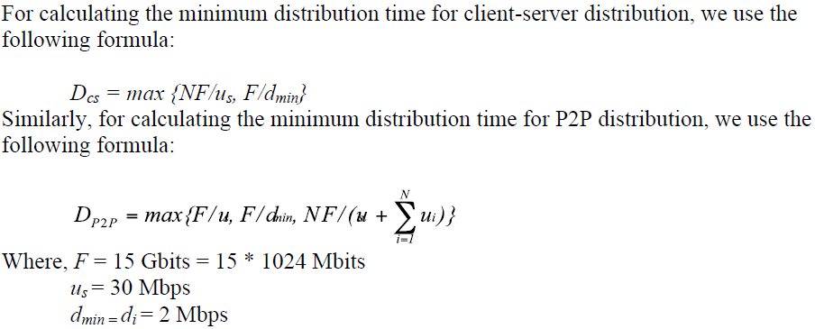

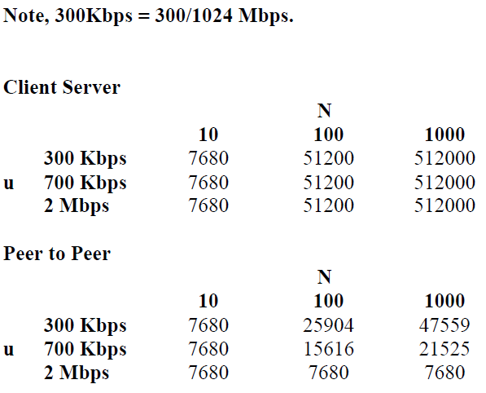

**Problem 2**

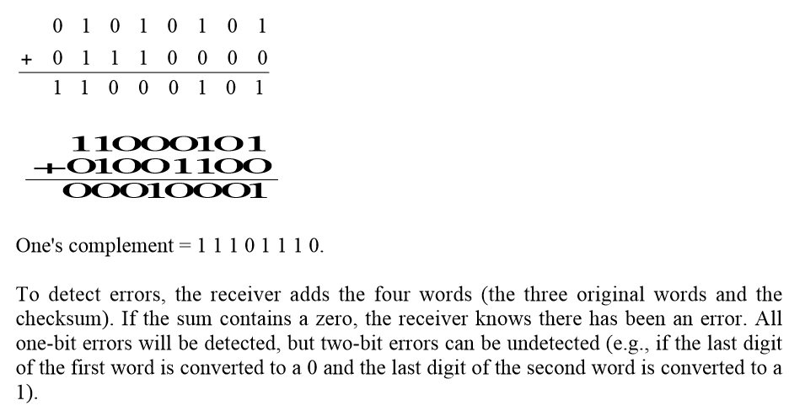

**Problem 3**

To best answer this question, consider why we needed sequence numbers in the first place. We saw that the sender needs sequence numbers so that the receiver can tell if a data packet is a duplicate of an already received data packet. In the case of ACKs, the sender does not need this info (i.e., a sequence number on an ACK) to tell detect a duplicate ACK. A duplicate ACK is obvious to the rdt3.0 receiver, since when it has received the original ACK it transitioned to the next state. The duplicate ACK is not the ACK that the sender needs and hence is ignored by the rdt3.0 sender.

**Problem 4**

With a NAK-based protocol, a lost packet will only be detected when a subsequent packet is correctly received by the receiver (which will then notice a gap in the received sequence numbers). This means that with infrequent data transmissions, a NAK based protocol can have a long error recovery time. Hence, a NAK-only protocol would not be desirable in this case. On the other hand, if errors are rate and the data rate is high, an ACK-based scheme is not desirable as there is high overhead (for the ACKs).

**Problem 5**

